These guidelines are provided for all Phase II proposal submissions to the NSMA Small Business Innovation Research Program (SBIR).

Table of Contents
INTRODUCTION 2
ELIGIBILITY AND LIMITATIONS 2
PROPOSAL PREPARATION/SUBMISSION 3
General Requirements 3
1. Period of Performance and Funding Limits: 3
2. Scope: 4
3. Contract Type: 4
4. Proprietary and Classified Information Markings: 4
5. Format: 4
6. Page Limit: 4
7. SBIR/STTR Transition Program (STP) Participation: 4
Technical Proposal 5
Cost Proposal 5
1. Offeror’s Direct Labor. 5
2. Consultants/Subcontractors. 5
3. Special tooling, testing, test equipment, and material. 5
4. Travel costs. 5
5. General & Administrative (G&A). 6
6. Facility Capital Cost of Money (FCCM). 6
7. Fixed Fee/Profit. 6
8. Approved Accounting System. 6
COMPANY COMMERCIALIZATION REPORT 6
APPENDIX A – NSMA SBIR/STTR Award Structure 7
APPENDIX B – Technology Readiness Levels and their Definitions 8

INTRODUCTION
The Navy Systems Management Activity Small Business Innovation Research (NSMA SBIR) program is a Systems Command (SYSCOM) under the Department of Navy (DON) SBIR/STTR programs which is managed by the Office of Naval Research, Office of Technology SBIR/STTR Division (ONR 03TSB). The following guidelines are provided for NSMA SBIR sponsored topics only.

ELIGIBILITY AND LIMITATIONS
All Phase I awardees are permitted to submit an initial Phase II proposal for evaluation and is due at the time of the Phase I final report. The purpose of this initial proposal is to protect small companies from expending unnecessary time and energy on developing a fully priced and detailed proposal that may be unlikely to obtain funding. ONLY firms that submit an initial Phase II proposal are eligible to submit a full Phase II proposal for potential award.

A NSMA Program Officer will evaluate the initial Phase II proposals and will submit recommendations to the NSMA SBIR Program Manager to request full Phase II proposals from selected firms. The notification to submit a full Phase II proposal is sent via email from a Contracting Officer or SBIR Coordinator designated by the NSMA SBIR Program office. A notification to submit does not guarantee that a Phase II contract will be awarded. NSMA reserves the right to make no award, one award, or more than one award under any topic.

The criteria listed below are used to determine which Phase I companies will be notified via email to submit a full Phase II proposal:
- Submitted an initial Phase II proposal at the end of the Phase I base award
- High quality Phase I effort
- High potential to satisfy an existing or future Naval need or problem
- Soundness, technical merit, and innovation of the proposed approach and its incremental progress toward topic or subtopic solution
- Qualifications of the proposed principal/key investigators, supporting staff, and consultants. Qualifications include not only the ability to perform the research and development but also the ability to commercialize the results
- Potential for commercialization (Government or private sector) application and the benefits expected to accrue from this commercialization
- NSMA SBIR Program Manager and NSMA Program Officer’s concurrence

Note: Any contractor proposing research that requires human, animal and recombinant DNA use is advised to view requirements at: http://www.onr.navy.mil/en/About-ONR/compliance-protections/Research-Protections/Human-Subject-Research.aspx. This website provides guidance and notes approvals that may be required before contract work may begin.

Each proposing firm must:
- Have been awarded a Phase I contract,
- Have submitted an initial Phase II proposal,
- Be notified via email to submit a full Phase II proposal by the Contracting Officer or SBIR Coordinator designated by the NSMA SBIR PM,
- Continue to qualify as a small business (defined in the most recent DoD SBIR Solicitation and certify to this on the Cover Sheet of the proposal),
- Perform a minimum of one-half of the research or research and development effort in house,
- Primarily employ the Principal Investigator at the time of award and during the conduct of the proposed effort (primary employment means that more than one-half of the principal investigator's time is spent with the small business),
- Perform the research or research and development within the United States ("United Sates" means the fifty states, the Territories and possessions of the United States, the Commonwealth of Puerto Rico, the Commonwealth of the Northern Mariana Islands, the Trust Territory of the Pacific Islands, and the District of Columbia),
- Complete electronic annual representations and certifications at https://www.sam.gov/portal/public/SAM/.
- Be registered in the System for Award Management (SAM), www.sam.gov. This means that –
  - The offeror has entered all mandatory information, including the DUNS number or the DUNS+4 number, the Contractor and Government Entity (CAGE) code, as well as data required by the Federal Funding Accountability and Transparency Act of 2006, into the SAM database;
  - The offeror has completed the Core, Assertions, and Representations and Certification, and Points of contact sections of the registration in the SAM database;
  - The Government has validated all mandatory data fields, to include validation of the Taxpayer Identification Number (TIN) with the Internal Revenue Service (IRS). The offeror will be required to provide consent for TIN validation to the Government as a part of the SAM registration process; and,
  - The Government has marked the record “Active”.

PROPOSAL PREPARATION/SUBMISSION
General Requirements: Submissions to NSMA must comply with all instructions contained in the most recent DoD SBIR solicitation, including those in the Navy instruction. Electronic submissions of SBIR Full Phase II proposals to the DoD SBIR /STTR Submission website are required at https://sbir.defensebusiness.org/user/login.

The submission process includes:
- Completing the DoD Phase II Proposal Cover Sheet online,
- Completing the DoD Company Commercialization Report online, and
- Uploading ONE (1) document that includes the technical proposal template, the proposal checklist, and the cost proposal.

After submission is complete, email the cost proposal (in Excel format) to the Contracting Officer designated in your notification.

Offerors should adhere to the following NSMA technical proposal and cost proposal preparation requirements:

- Period of Performance and Funding Limits.
- Phase II Base: Phase II proposals should have a base period of approximately 24 months and are funded up to $600K. Base periods can be for less money but will rarely be funded for more than $600K.
- Phase II Option 1: Companies should submit a Phase II Option 1 with a performance period of approximately 6 months, funded up to $150K. A Technology Transition Plan (TTP), coordinated and signed by the office transitioning the technology, is required prior to exercising this option. The option Phase usually includes test and evaluation work along with activities required to mature the technology so that it can be implemented into a targeted DoD application.
- Scope. The proposed Phase II effort should be based on further development of the technological innovation performed in Phase I, should stay within the scope of the solicitation topic, and should have high potential to provide new or improved products, processes, or services to the Navy and/or other Defense components possibly with additional benefits to the commercial and private sector. In assessing the DoD market, offerors are encouraged to use various resources, including the free technical information services available from the Defense Technical Information Center (DTIC) and other information assistance organizations noted in the most recent DoD Solicitation. First-time awardees should register as a Phase I contractor at DTIC to access the DTIC's databases. The DTIC SBIR internet link is: http://www.dtic.mil/dtic/
- Contract Type. The proposal must be for a Cost Plus Fixed Fee (CPFF) type contract. At the time of award the contractor must have a job-order-based accounting system capable of accruing costs under a government CPFF contract. A list of Defense Contract Management District East and West Associate Small Business Directors can be obtained at: http://www.dcma.mil/DCMAHQ/smallbusiness/contact.cfm. This award will be contracted out of the Naval Air Systems Command.
- Proprietary and Classified Information Markings. Submissions must comply with all relevant instructions contained in the most recent DoD solicitation on markings required for proprietary and classified information. Do not include proprietary information or classified information in the coversheet abstract or benefits sections (on-line submission).
- Format. Use one-inch margins and a font size no smaller than 10 point.
- Page Limit. Limit your technical content section to 50 pages including the option but excluding the Supporting Material and Cost Proposal. All pages from the first through the last must be consecutively numbered.
- SBIR/STTR Transition Program (STP) Participation. All Phase II award winners must attend a one-day STP meeting in the Washington D.C. area during the first or second year of the Phase II effort. Recommend budgeting at least one trip to Washington in your Phase II cost proposal.

Technical Proposal: As a guide, the “Technical Proposal Template” document included with your notification should be used as a template for your proposal.

Cost Proposal: Please use the “Cost Proposal Spreadsheet” provided in your email notification. This spreadsheet should be combined with the technical document and uploaded as one file to the DoD Submission website. It is NOT necessary to complete the DoD Cost Proposal form. A thoroughly itemized cost proposal can significantly reduce the amount of time required for contract negotiation and the cost proposal template has all of the necessary requirements listed. Costs must be included for the Phase II base effort and for a Phase II option. If an item does not apply to the proposed effort, state, “Not Applicable.” For proprietary reasons, subcontractors, consultants, or vendors may want to give you only bottom line quotes. In such cases, detailed quotes should be sent directly to the government Contracting Officer identified in your notification letter. Documentation/quotes for materials, equipment, travel, and other ODCs must be provided as well. The following descriptions illustrate the level of cost detail that a Contracting Officer requires before beginning negotiations.

- Offeror’s Direct Labor. List all key personnel by name and other personnel by labor category; e.g., senior scientist. Specify the number of hours to be dedicated to the project and hourly costs for each.
- Consultants/Subcontractors. List consultants by name and specify, for each, the number of hours and hourly costs. Detailed quotes from subcontractors should be provided in the same format. Note that a subcontract entered into for performance of research or research and development differs from an arrangement with a vendor to provide a service such as machining, analysis with test equipment, use of computer time, and the like. The costs of such arrangements with vendors should be covered under Special Tooling, Testing, Test Equipment, and Material or under Other Direct Costs. The subcontractor’s, for government eyes only, cost proposals may be provided as sealed attachments to the prime’s proposal or emailed directly to the government Contracting Officer from the subcontractor.
- Special Tooling, Testing, Test Equipment, and Material. The need for these items, if proposed, will be carefully reviewed. The offeror should provide competitive quotes to support the proposed costs or should justify why only one source is available. Competitive quotes may be signed quotes from vendors or copies of catalogue pages. Normally the costs of any equipment should be quoted on a purchase basis, unless the offeror can demonstrate that lease or rent of the equipment is clearly advantageous to the Government. The Contracting Officer will make the final determination.
- Travel costs. Travel (i.e. airfares, car rental and per diem) must be justifiable in terms of the proposed effort. Specify how many people will travel to what places for how many days. Please note that all Phase II award winners must attend a one-day SBIR/STTR Transition Program (STP) meeting in the Washington D.C. area no later than the second year of the Phase II effort. Recommend budgeting at least one trip to Washington, DC.
- General & Administrative (G&A). If applicable, include your G&A rate and its application base consistent with your approved accounting system.
- Facility Capital Cost of Money (FCCM). If applicable, include your FCCM rate(s) and its application base consistent with your approved accounting system.
- Fixed Fee/Profit. If applicable, include the proposed fixed fee/profit.
- Approved Accounting System. If you have an approved accounting system, and your indirect costs have been reviewed by a Government auditor, provide the name, address, and telephone number, of that auditor. If your accounting system has not been approved by the Government auditor, please provide a description of your accounting system, and the method you used to compute your indirect costs. (Include the details of indirect cost pools and the base against which they are applied as summarized above.)

COMPANY COMMERCIALIZATION REPORT
All SBIR and STTR proposals must be accompanied by an on-line report that summarizes the “value” of all prior SBIR & STTR awards to the offeror. The on-line data entry forms for the Company Commercialization Report are accessible from the DoD SBIR/STTR Submission website at https://sbir.defensebusiness.org/user/login and will automatically be combined with your Phase II proposal. Please be sure that you have updated this report on the site prior to submitting your proposal.

Any relevant success stories which resulted directly from a Phase I or Phase II award may be summarized briefly and submitted separately through the Navy SBIR website at http://www.navysbir.com/navsuccess.htm. A Navy success story should include any follow-on funding that a firm has received based on technology developed from a Navy SBIR or STTR Phase II award. The success stories should be included as appendices to the proposal. The success story information will be used as part of the evaluation criteria, Commercial Potential, which includes the Company’s Commercialization Report and the strategy described to commercialize the technology discussed in the proposal. The Navy is very interested in companies that transition SBIR efforts directly into Navy and DoD programs and/or weapon systems. If a firm has never received a Navy SBIR Phase II it will not count against them.

APPENDIX A – NSMA SBIR/STTR Program Award Structure

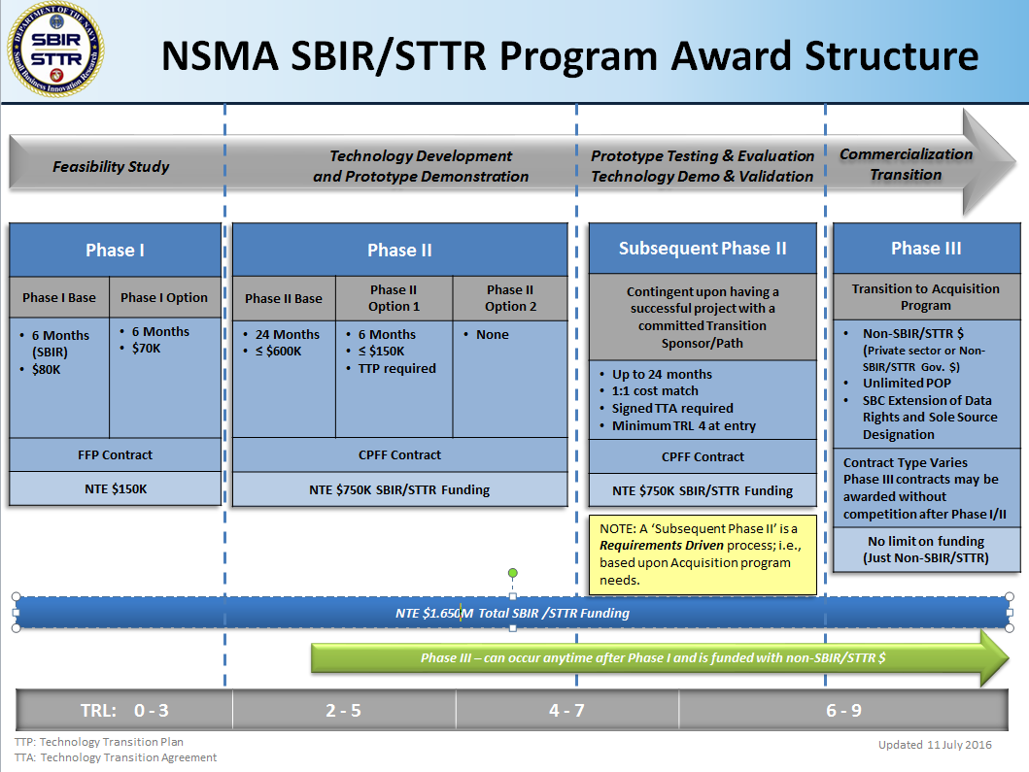

APPENDIX B - Technology Readiness Levels and their Definitions

Technology Readiness Levels
The following matrix lists the various technology readiness levels and descriptions from a systems approach for both hardware and software. DoD Components may provide additional clarifications for software. Supplemental definitions follow the table.

Technology Readiness Level | Description
1. Basic principles observed and reported. | Lowest level of technology readiness. Scientific research begins to be translated into applied research and development. Examples might include paper studies of a technology’s basic properties.
2. Technology concept and/or application formulated. | Invention begins. Once basic principles are observed, practical applications can be invented. Applications are speculative and there may be no proof or detailed analysis to support the assumptions. Examples are limited to analytic studies.
3. Analytical and experimental critical function and/or characteristic proof of concept. | Active research and development is initiated. This includes analytical studies and laboratory studies to physically validate analytical predictions of separate elements of the technology. Examples include components that are not yet integrated or representative.
4. Component and/or breadboard validation in laboratory environment. | Basic technological components are integrated to establish that they will work together. This is relatively “low fidelity” compared to the eventual system. Examples include integration of “ad hoc” hardware in the laboratory.
5. Component and/or breadboard validation in relevant environment. | Fidelity of breadboard technology increases significantly. The basic technological components are integrated with reasonably realistic supporting elements so it can be tested in a simulated environment. Examples include “high fidelity” laboratory integration of components.
6. System/subsystem model or prototype demonstration in a relevant environment. | Representative model or prototype system, which is well beyond that of TRL 5, is tested in a relevant environment. Represents a major step up in a technology’s demonstrated readiness. Examples include testing a prototype in a high-fidelity laboratory environment or in simulated operational environment.
7. System prototype demonstration in an operational environment. | Prototype near, or at, planned operational system. Represents a major step up from TRL 6, requiring demonstration of an actual system prototype in an operational environment such as an aircraft, vehicle, or space. Examples include testing the prototype in a test bed aircraft.
8. Actual system completed and qualified through test and demonstration. | Technology has been proven to work in its final form and under expected conditions. In almost all cases, this TRL represents the end of true system development. Examples include developmental test and evaluation of the system in its intended weapon system to determine if it meets design specifications.
9. Actual system proven through successful mission operations. | Actual application of the technology in its final form and under mission conditions, such as those encountered in operational test and evaluation. Examples include using the system under operational mission conditions.

DEFINITIONS:

Breadboard: Integrated components that provide a representation of a system/subsystem and which can be used to determine concept feasibility and to develop technical data. Typically configured for laboratory use to demonstrate the technical principles of immediate interest. May resemble final system/subsystem in function only.

High Fidelity: Addresses form, fit and function. High-fidelity laboratory environment would involve testing with equipment that can simulate and validate all system specifications within a laboratory setting.

Low Fidelity: A representative of the component or system that has limited ability to provide anything but first order information about the end product. Low-fidelity assessments are used to provide trend analysis.

Model: A functional form of a system generally reduced in scale, near or at operational specification. Models will be sufficiently hardened to allow demonstration of the technical and operational capabilities required of the final system.

Operational Environment: Environment that addresses all of the operational requirements and specifications required of the final system to include platform/packaging.

Prototype: A physical or virtual model used to evaluate the technical or manufacturing feasibility or military utility of a particular technology or process, concept, end item or system.

Relevant Environment: Testing environment that simulates the key aspects of the operational environment.

Simulated Operational Environment: Either 1) a real environment that can simulate all of the operational requirements and specifications required of the final system, or 2) a simulated environment that allows for testing of a virtual prototype; used in either case to determine whether a developmental system meets the operational requirements and specifications of the final system.

. A TTP is a transition plan written by either the company or the technical monitor and reviewed by the PEO/FNC SBIR technology manager and the NSMA SBIR program manager for continuity with the program of record’s transition roadmap. A TTA is a detailed transition agreement, written by either the company or the technical monitor and signed by the acquisition program office and the cost-share funding source, agreeing to the transition of the technology. Templates will be provided by the NSMA SBIR program office.

